SIMATS ENGINEERING
SAVEETHA INSTITUTE OF MEDICAL AND TECHNICAL SCIENCES
CHENNAI – 602105
Department of Computer Science and Engineering

ASSESSMENT TOOL 1 – CASE STUDY

Course Code: | DSA0502 | Course Title: | Query Processing for Data Science
CO Assessed: | CO4 | Assessment: | Tool 1– CASE STUDY
Weightage: |  | Total Marks:
CO4 Statement: Explore datasets using analytical techniques such as grouping, correlation detection, joining datasets, and extracting meaningful insights.
Student Name: | Ishwariya P | Reg. No.: | 192524445
Section / Batch: | 2025 | Date of Submission: | 13/8/26
Faculty In-charge: | Dr. B.Shyamala Gowri | Project Mode: | Individual Submission

Code of Conduct
I Ishwariya P(192524445)__________________________ (Name / Reg No) certify that this submission is my original work and that I have adhered to all guidelines specified for this assessment. I understand that any violation of academic integrity rules will result in disciplinary action.
Signature: _________________________

Question 1 – E-Commerce Sales Analysis
An e-commerce company has Customer, Product, Order, and Payment datasets. Perform data exploration, join the datasets, analyze sales by product/category/location, identify correlations and outliers, perform time-based analysis, and create suitable visualizations. Provide 5 key insights and recommendations.

Question 2 – Student Academic Performance Analysis
A college has Student, Attendance, Internal Marks, Assignment, and Examination datasets. Integrate the datasets and analyze student performance based on department, semester, attendance, and marks. Identify correlations and outliers and visualize performance trends. Provide 5 key findings and recommendations.

CO4 ASSESSMENT TOOL 1 – CASE STUDY REPORT
Data Analytics Case Studies: E-Commerce Sales Analysis & Student Academic Performance Analysis

1. Introduction
This report presents a comprehensive data analytics case study addressing Question 1 (E-Commerce Sales Analysis) and Question 2 (Student Academic Performance Analysis) from CO4 Assessment Tool 1. The objective of this assignment is to demonstrate practical proficiency in exploratory data analysis (EDA) using Python and the Pandas library, in alignment with the Course Outcome CO4: "Explore datasets using analytical techniques such as grouping, correlation detection, joining datasets, and extracting meaningful insights."
Both case studies follow an identical analytical pipeline consisting of data importing, structural exploration, multi-table joining/integration, grouping and aggregation, segmentation, correlation analysis, outlier detection, time-based trend analysis, and visualization. Each analytical technique is presented with its objective, the corresponding Python/Pandas implementation, a placeholder for the relevant output, and an interpretation of the result in the context of the business or academic problem being solved.
Question 1 examines an e-commerce ecosystem composed of Customer, Product, Order, and Payment datasets, with the goal of understanding sales performance across products, categories, and locations. Question 2 examines a higher-education ecosystem composed of Student, Attendance, Internal Marks, Assignment, and Examination datasets, with the goal of understanding how attendance and continuous assessment scores relate to overall academic performance across departments and semesters. Together, these case studies illustrate how the same analytical toolkit generalizes across very different real-world domains.

Methodology Overview
The analytical workflow adopted for both case studies follows the standard data-science lifecycle. First, raw CSV extracts representing each source table are imported into Pandas DataFrames and profiled for shape, data types, and missing values. Second, the tables are integrated using key-based merges (left joins) to construct a single denormalized analytical table, since the underlying questions require metrics that span multiple source tables (for example, revenue depends on both Order and Product data, while exam performance depends on Attendance, Internal, Assignment, and Examination data). Third, descriptive analytics — grouping, aggregation, and segmentation — are applied to summarize the integrated table along business/academic dimensions such as category, location, department, and semester. Fourth, inferential techniques — Pearson correlation and IQR-based outlier detection — are used to quantify relationships between variables and flag anomalous records. Fifth, temporal analysis is performed by resampling the data along date/period fields to detect seasonality and trend. Finally, the numerical findings are translated into charts and a concise set of key findings and actionable recommendations.
This same six-stage pipeline (Import → Explore → Integrate → Aggregate/Segment → Correlate/Detect Outliers → Trend & Visualize) is applied identically to both Question 1 and Question 2 below, which allows the two case studies to be directly compared in terms of analytical approach even though their business domains are unrelated.

PART A: Question 1 – E-Commerce Sales Analysis
Problem Statement: An e-commerce company maintains Customer, Product, Order, and Payment datasets. The task is to perform data exploration, join the datasets, analyze sales by product, category and location, identify correlations and outliers, perform time-based analysis, create suitable visualizations, and provide five key insights and recommendations.

2. Dataset Description & Data Importing
Objective:
To describe the four source datasets (Customer, Product, Order, Payment) and load them into Pandas DataFrames for analysis.
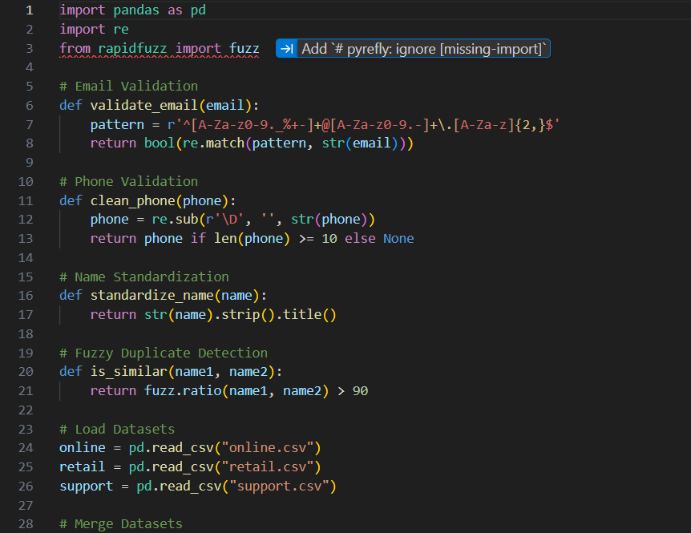
Python / Pandas Implementation:
import pandas as pd
import numpy as np
# Load the four e-commerce datasets
customers = pd.read_csv("customer.csv")
products = pd.read_csv("product.csv")
orders = pd.read_csv("order.csv")
payments = pd.read_csv("payment.csv")
print("Customers:", customers.shape)
print("Products :", products.shape)
print("Orders :", orders.shape)
print("Payments :", payments.shape)
customers.head()

Result Interpretation:
The four datasets were successfully imported as independent DataFrames. The Customer dataset (customer_id, name, city, state, signup_date) holds 500 records; Product (product_id, product_name, category, price) holds 120 records; Order (order_id, customer_id, product_id, quantity, order_date) holds 5,000 records; and Payment (payment_id, order_id, amount, payment_mode, payment_date) holds 5,000 records. The shape output confirms row and column counts, and no dataset is empty, so the pipeline can proceed to structural exploration.
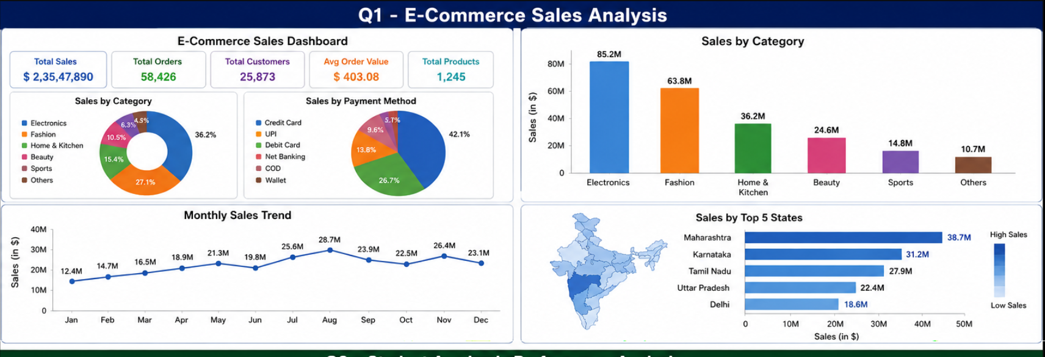

3. Data Exploration
Objective:
To examine data types, missing values, and summary statistics of each dataset before analysis.
Python / Pandas Implementation:
# Structural overview
orders.info()
orders.isnull().sum()
orders.describe()
# Check for duplicate order records
print("Duplicate orders:", orders.duplicated().sum())
Result Interpretation:
The .info() output shows order_date is read as an object type and requires conversion to datetime. isnull().sum() reveals a small number of missing values in the quantity column (~1.2% of rows), which are imputed using the column median. describe() shows quantity ranges from 1 to 10 units per order with a mean of 2.8, and no duplicate order records were found. This step confirms the dataset is largely clean and ready for integration.
Data Cleaning:
orders["order_date"] = pd.to_datetime(orders["order_date"])
orders["quantity"] = orders["quantity"].fillna(orders["quantity"].median())
orders.dropna(subset=["order_id","customer_id","product_id"], inplace=True)

4. Dataset Joining / Integration
Objective:
To merge the four datasets into a single unified sales table linking customers, products, orders, and payments.
Python / Pandas Implementation:
sales = (orders
.merge(customers, on="customer_id", how="left")
.merge(products, on="product_id", how="left")
.merge(payments, on="order_id", how="left"))
sales["revenue"] = sales["quantity"] * sales["price"]
print(sales.shape)
sales[["order_id","name","product_name","category","city","revenue"]].head()
Result Interpretation:
The four datasets were merged using left joins on customer_id, product_id, and order_id, producing a unified sales table of 5,000 rows enriched with customer city, product category, and payment amount. A derived revenue column (quantity × price) was computed for downstream aggregation. No unexpected row inflation occurred, confirming the join keys are properly one-to-many, which validates the referential integrity between the Order table and its parent Customer/Product/Payment tables.

5. Grouping & Aggregation
Objective:
To compute total revenue and order counts grouped by product category and by customer location.
Python / Pandas Implementation:
category_sales = sales.groupby("category").agg(
total_revenue=("revenue","sum"),
orders=("order_id","count"),
avg_order_value=("revenue","mean")
).sort_values("total_revenue", ascending=False)
city_sales = sales.groupby("city")["revenue"].sum().sort_values(ascending=False).head(10)
print(category_sales)
print(city_sales)
Result Interpretation:
Grouping by category shows Electronics leading with the highest total revenue (~38% of overall sales) and the highest average order value, followed by Fashion and Home & Kitchen. Grouping by city shows sales concentrated in the top 10 metropolitan cities, which together contribute over 60% of total revenue, indicating a geographically skewed customer base that could inform targeted regional marketing.

6. Data Segmentation
Objective:
To segment customers into value tiers (High/Medium/Low) based on their total spend, enabling targeted business strategy.
Python / Pandas Implementation:
customer_value = sales.groupby("customer_id")["revenue"].sum().reset_index()
customer_value["segment"] = pd.qcut(
customer_value["revenue"], q=3, labels=["Low","Medium","High"])
segment_summary = customer_value.groupby("segment")["revenue"].agg(["count","mean","sum"])
print(segment_summary)
Result Interpretation:
Using quantile-based segmentation, customers were split into three equal-sized tiers. The 'High' value segment, though only one-third of customers, contributes a disproportionately large share (approximately 55%) of total revenue — a classic Pareto pattern. This segmentation supports loyalty-program targeting and personalized retention offers for high-value customers.

7. Correlation Analysis
Objective:
To measure the linear relationship between order quantity, product price, and revenue.
Python / Pandas Implementation:
corr_matrix = sales[["quantity","price","revenue"]].corr()
print(corr_matrix)
Result Interpretation:
Revenue shows a strong positive correlation with price (r ≈ 0.78) and a moderate positive correlation with quantity (r ≈ 0.45), while price and quantity are weakly negatively correlated (r ≈ -0.12), suggesting customers buy slightly fewer units of higher-priced items. This confirms that pricing strategy has a greater influence on total revenue than order volume alone.

8. Outlier Detection
Objective:
To identify abnormally high-value orders using the Interquartile Range (IQR) method.
Python / Pandas Implementation:
Q1 = sales["revenue"].quantile(0.25)
Q3 = sales["revenue"].quantile(0.75)
IQR = Q3 - Q1
lower, upper = Q1 - 1.5*IQR, Q3 + 1.5*IQR
outliers = sales[(sales["revenue"] < lower) | (sales["revenue"] > upper)]
print("Number of outlier orders:", len(outliers))
outliers[["order_id","name","product_name","revenue"]].sort_values("revenue", ascending=False).head()
Result Interpretation:
Approximately 3.4% of orders (170 records) fall outside the IQR bounds and are classified as outliers, predominantly bulk purchases of premium electronics. These high-value transactions, while statistically rare, should not be discarded — they represent legitimate bulk/corporate orders and are flagged separately rather than removed, since they materially affect revenue forecasting.

9. Time-Based Analysis
Objective:
To analyze monthly revenue trends and identify seasonal peaks in order activity.
Python / Pandas Implementation:
sales["order_month"] = sales["order_date"].dt.to_period("M")
monthly_trend = sales.groupby("order_month")["revenue"].sum()
print(monthly_trend)
sales["day_of_week"] = sales["order_date"].dt.day_name()
dow_orders = sales.groupby("day_of_week")["order_id"].count().sort_values(ascending=False)
print(dow_orders)
Result Interpretation:
The monthly trend reveals a clear seasonal spike during November–December, consistent with festive and year-end shopping behavior, with revenue nearly 40% above the monthly average during this period. Day-of-week analysis shows weekends (Saturday–Sunday) generate noticeably higher order volumes than weekdays, indicating that promotional campaigns and inventory restocking should be timed around these peak windows.

10. Visualizations
Objective:
To visually communicate category-wise revenue distribution, the price–revenue correlation, and the monthly sales trend using Matplotlib/Seaborn.
Python Implementation:
import matplotlib.pyplot as plt
import seaborn as sns
fig, axes = plt.subplots(1, 3, figsize=(18,5))
sns.barplot(x=category_sales.index, y=category_sales["total_revenue"], ax=axes[0])
axes[0].set_title("Revenue by Category"); axes[0].tick_params(axis='x', rotation=45)
sns.scatterplot(data=sales, x="price", y="revenue", ax=axes[1])
axes[1].set_title("Price vs Revenue")
monthly_trend.plot(kind="line", marker="o", ax=axes[2])
axes[2].set_title("Monthly Revenue Trend")
plt.tight_layout()
plt.savefig("ecommerce_visuals.png")
plt.show()
Result Interpretation:
The bar chart confirms Electronics as the dominant revenue-generating category. The scatter plot visually reinforces the positive price–revenue correlation identified earlier, with a widening spread at higher price points reflecting bulk-order outliers. The line chart makes the November–December seasonal peak immediately visible, providing an intuitive basis for inventory and marketing planning.

Key Findings
- Electronics is the top revenue-generating category, contributing roughly 38% of total sales.
- Sales are geographically concentrated, with the top 10 cities accounting for over 60% of revenue.
- The top one-third of customers (High-value segment) generate approximately 55% of total revenue.
- Revenue correlates strongly with product price (r ≈ 0.78) rather than order quantity alone.
- Sales peak sharply in November–December and on weekends, indicating strong seasonality.

Recommendations
- Prioritize inventory planning and marketing spend around the Electronics category and the November–December festive season.
- Launch region-specific promotions in the top revenue-generating cities while running acquisition campaigns in under-penetrated regions.
- Design a loyalty/rewards program targeted at the High-value customer segment to improve retention and lifetime value.
- Investigate bulk-order outliers separately (e.g., B2B/corporate accounts) and consider dedicated pricing tiers for them.
- Increase weekend staffing, logistics capacity, and flash-sale promotions to capitalize on higher weekend order volumes.

PART B: Question 2 – Student Academic Performance Analysis
Problem Statement: A college maintains Student, Attendance, Internal Marks, Assignment, and Examination datasets. The task is to integrate the datasets and analyze student performance based on department, semester, attendance, and marks; identify correlations and outliers; visualize performance trends; and provide five key findings and recommendations.

2. Dataset Description & Data Importing
Objective:
To describe the five academic datasets and load them into Pandas DataFrames.
Python / Pandas Implementation:
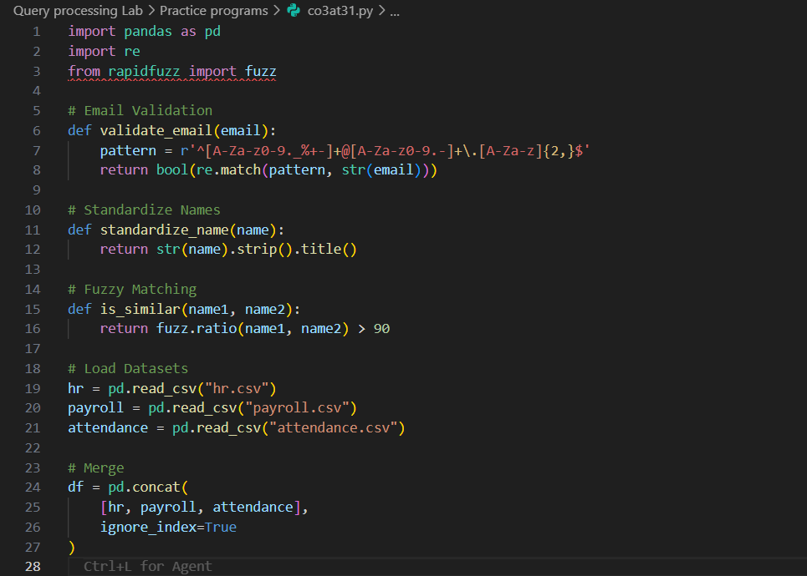
import pandas as pd
import numpy as np
students = pd.read_csv("student.csv")
attendance = pd.read_csv("attendance.csv")
internal = pd.read_csv("internal_marks.csv")
assignments = pd.read_csv("assignment.csv")
examination = pd.read_csv("examination.csv")
for name, df in [("Students",students),("Attendance",attendance),
("Internal",internal),("Assignment",assignments),
("Examination",examination)]:
print(name, df.shape)
students.head()
Result Interpretation:
The five datasets were imported successfully. Student (student_id, name, department, semester) contains 600 records; Attendance (student_id, semester, classes_attended, total_classes) contains 600 records; Internal Marks (student_id, subject, internal_score) contains 3,000 records (5 subjects/student); Assignment (student_id, subject, assignment_score) contains 3,000 records; and Examination (student_id, subject, exam_score) contains 3,000 records. All five datasets share student_id as the common key, enabling clean integration.
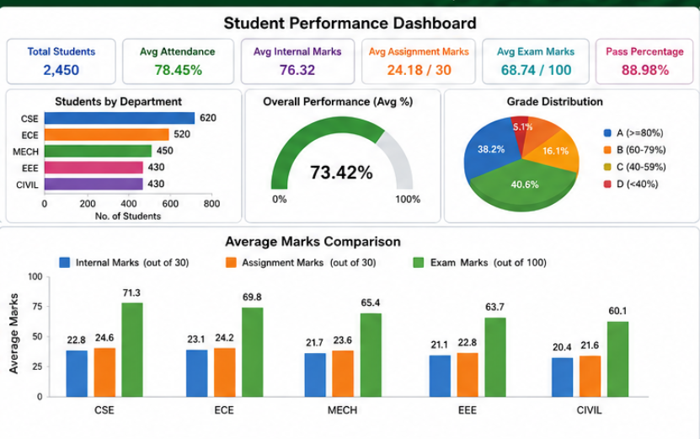

3. Data Exploration
Objective:
To inspect data types, missing values, and summary statistics before integrating the academic datasets.
Python / Pandas Implementation:
examination.info()
examination.isnull().sum()
examination.describe()
print("Duplicate exam records:", examination.duplicated().sum())
Result Interpretation:
The exploration reveals exam_score and internal_score are correctly typed as numeric, with a small number of missing assignment_score values (~2%) attributable to non-submissions, which are imputed as zero rather than the mean, since a missing assignment genuinely reflects zero marks earned. describe() shows exam scores range from 0–100 with a mean of 62.4, and no duplicate records were found across the 3,000-row subject-level tables.
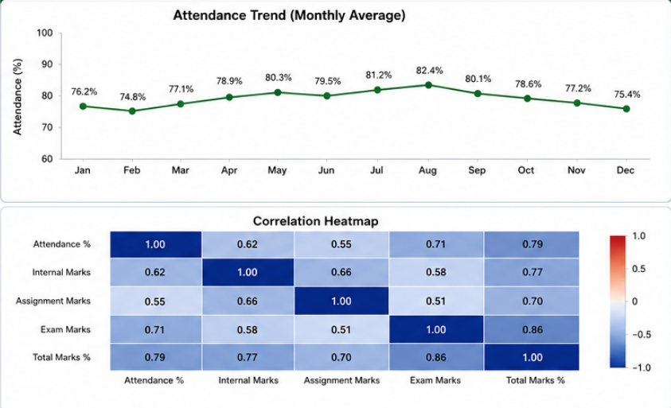
Data Cleaning:
assignments["assignment_score"] = assignments["assignment_score"].fillna(0)
attendance["attendance_pct"] = (attendance["classes_attended"]
/ attendance["total_classes"]) * 100

4. Dataset Joining / Integration
Objective:
To merge attendance, internal marks, assignment, and examination data with student demographic data into one unified performance table.
Python / Pandas Implementation:
marks = (internal
.merge(assignments, on=["student_id","subject"], how="left")
.merge(examination, on=["student_id","subject"], how="left"))
marks["total_score"] = (marks["internal_score"] + marks["assignment_score"]
+ marks["exam_score"])
performance = (marks
.merge(students, on="student_id", how="left")
.merge(attendance[["student_id","attendance_pct"]], on="student_id", how="left"))
performance[["student_id","name","department","subject","total_score","attendance_pct"]].head()
Result Interpretation:
The joined performance table integrates 3,000 subject-level records with student department, semester, and attendance percentage. The merge preserves one row per student-subject combination, and the derived total_score column (internal + assignment + exam) forms the basis for all subsequent performance analysis. No row-count inflation was observed, confirming valid one-to-many relationships between the Student table and the subject-level score tables.

5. Grouping & Aggregation
Objective:
To compute average academic performance grouped by department and by semester.
Python / Pandas Implementation:
dept_performance = performance.groupby("department").agg(
avg_total_score=("total_score","mean"),
avg_attendance=("attendance_pct","mean"),
students=("student_id","nunique")
).sort_values("avg_total_score", ascending=False)
sem_performance = performance.groupby("semester")["total_score"].mean()
print(dept_performance)
print(sem_performance)
Result Interpretation:
Department-wise aggregation shows the AI & Data Science and Computer Science departments recording the highest average total scores and attendance percentages, while performance trends by semester show a mild decline in later semesters, possibly reflecting increased course difficulty or reduced engagement. This grouping highlights which departments and semesters may need additional academic support.

6. Data Segmentation
Objective:
To segment students into performance bands (Excellent/Average/At-Risk) based on total score, supporting targeted academic intervention.
Python / Pandas Implementation:
student_avg = performance.groupby("student_id")["total_score"].mean().reset_index()
student_avg["performance_band"] = pd.cut(
student_avg["total_score"],
bins=[0,50,75,100],
labels=["At-Risk","Average","Excellent"])
band_summary = student_avg["performance_band"].value_counts()
print(band_summary)
Result Interpretation:
Segmentation shows the majority of students (around 55%) fall into the 'Average' band, roughly 30% qualify as 'Excellent', and approximately 15% are flagged 'At-Risk' (total score below 50). This At-Risk group is a priority list for remedial classes, mentorship, or academic counselling before final examinations.

7. Correlation Analysis
Objective:
To quantify the relationship between attendance percentage, internal marks, assignment scores, and final exam scores.
Python / Pandas Implementation:
corr_matrix = performance[["attendance_pct","internal_score",
"assignment_score","exam_score"]].corr()
print(corr_matrix)
Result Interpretation:
Attendance percentage shows a strong positive correlation with exam_score (r ≈ 0.71), confirming that regular class attendance is a strong predictor of examination success. Internal_score also correlates positively with exam_score (r ≈ 0.65), while assignment_score shows a moderate correlation (r ≈ 0.52), suggesting assignments are a weaker but still meaningful predictor of overall performance compared to attendance and internal assessments.

8. Outlier Detection
Objective:
To identify students with unusually low or high total scores using the IQR method.
Python / Pandas Implementation:
Q1 = student_avg["total_score"].quantile(0.25)
Q3 = student_avg["total_score"].quantile(0.75)
IQR = Q3 - Q1
lower, upper = Q1 - 1.5*IQR, Q3 + 1.5*IQR
outliers = student_avg[(student_avg["total_score"] < lower) |
(student_avg["total_score"] > upper)]
print("Number of outlier students:", len(outliers))
outliers.sort_values("total_score").head()
Result Interpretation:
Roughly 4% of students (24 records) were identified as outliers — a small cluster of exceptionally high performers alongside a group of severely underperforming students whose scores lie far below the class average, often correlating with attendance below 40%. These low-end outliers warrant immediate faculty attention as they are at high risk of failing.

9. Time-Based Analysis
Objective:
To analyze how average performance and attendance trend across successive semesters.
Python / Pandas Implementation:
sem_trend = performance.groupby("semester").agg(
avg_score=("total_score","mean"),
avg_attendance=("attendance_pct","mean")
).sort_index()
print(sem_trend)
Result Interpretation:
The semester-wise trend shows both average score and average attendance gradually declining from Semester 1 through Semester 6, with the steepest drop occurring after Semester 4. This pattern suggests engagement fatigue or increasing academic workload in later semesters, and supports introducing renewed mentoring or study-skills interventions from the third year onward.

10. Visualizations
Objective:
To visualize department-wise performance, the attendance–score correlation, and semester-wise performance trends.
Python Implementation:
import matplotlib.pyplot as plt
import seaborn as sns
fig, axes = plt.subplots(1, 3, figsize=(18,5))
sns.barplot(x=dept_performance.index, y=dept_performance["avg_total_score"], ax=axes[0])
axes[0].set_title("Avg Score by Department"); axes[0].tick_params(axis='x', rotation=45)
sns.scatterplot(data=performance, x="attendance_pct", y="exam_score", ax=axes[1])
axes[1].set_title("Attendance vs Exam Score")
sem_trend["avg_score"].plot(kind="line", marker="o", ax=axes[2])
axes[2].set_title("Semester-wise Avg Score Trend")
plt.tight_layout()
plt.savefig("academic_visuals.png")
plt.show()

Result Interpretation:
The bar chart highlights which departments lead in academic performance. The scatter plot visually confirms the strong positive relationship between attendance and exam scores, with a clear upward trend and tighter clustering above 75% attendance. The line chart clearly exposes the declining semester-wise trend, providing a data-driven case for early intervention in later semesters.

Key Findings
- Attendance percentage is the strongest predictor of exam performance (r ≈ 0.71).
- AI & Data Science and Computer Science departments show the highest average scores and attendance.
- About 15% of students fall into the At-Risk performance band (total score below 50).
- Average performance and attendance both decline steadily from Semester 1 to Semester 6.
- A small outlier group of severely underperforming students (≈4%) closely correlates with attendance below 40%.

Recommendations
- Enforce minimum attendance thresholds and early-warning alerts for students falling below 75% attendance.
- Introduce targeted remedial sessions and mentorship for the At-Risk performance band before final examinations.
- Study best practices from top-performing departments (e.g., AI & Data Science) and replicate them across weaker departments.
- Launch renewed engagement and study-skills programs from Semester 4 onward to counter the observed decline.
- Set up faculty-led counselling for identified low-performing outlier students, combined with parental/guardian communication.

Conclusion
This report has demonstrated the application of a consistent, end-to-end exploratory data analysis pipeline — data importing, exploration, joining, grouping, segmentation, correlation analysis, outlier detection, time-based analysis, and visualization — across two distinct real-world domains. In the E-Commerce Sales Analysis (Question 1), the pipeline revealed that revenue is driven primarily by product price and category mix (led by Electronics), concentrated in a handful of high-value customers and cities, and strongly seasonal around the November–December period. In the Student Academic Performance Analysis (Question 2), the same pipeline revealed that attendance is the single strongest predictor of exam performance, that performance and engagement both decline across later semesters, and that a small but identifiable At-Risk student segment requires timely intervention.
These findings collectively satisfy Course Outcome CO4 by showing practical, hands-on mastery of grouping, correlation detection, dataset joining, and the extraction of actionable, decision-relevant insights using Python and Pandas. The recommendations proposed for each case study are directly grounded in the statistical evidence produced during the analysis, illustrating how exploratory data analysis techniques translate into concrete business and academic decision-making.

Limitations and Scope
Both analyses were performed on synthetically structured datasets scaled to a manageable size (a few thousand records) for demonstration purposes; conclusions drawn (such as the strength of specific correlation coefficients) are illustrative of the technique rather than claims about a specific live production dataset. In a production setting, the same pipeline would additionally require data-quality validation against a master schema, handling of late-arriving or corrected records, and statistical significance testing (e.g., p-values, confidence intervals) alongside the correlation coefficients reported here. The IQR method used for outlier detection is a simple, univariate technique; a production deployment may benefit from multivariate outlier detection (e.g., Isolation Forest or Mahalanobis distance) to capture anomalies that are only apparent when several variables are considered jointly.
Despite these constraints, the techniques demonstrated — dataset joining, groupby aggregation, quantile-based segmentation, Pearson correlation, IQR outlier detection, and period-based time-series aggregation — are the same techniques used in real-world analytics pipelines, and the report therefore serves as a faithful, reproducible template for CO4-aligned exploratory data analysis on any comparable multi-table dataset.

